TITLE: HR-AlbedoMap Product User Guide

Author: | Prof. J-P Muller, Dr. R Song | Date: | 20/10/2021
Manager/Project Office |  | Date:
PA: |  | Date:

CHANGE RECORD

ISSUE | DATE | PAGES CHANGED | COMMENTS
1 | 20/10/21 | All new | First Issue

CONTRIBUTORS

Author Names | Organisation
J.-P. Muller, R. Song | UCL MSSL

CONTENTS

1 Introduction 4
1.1 Purpose and Scope of Document 4
1.2 Definitions 4
2 Processing Environment 4
2.1 Overview of the processing framework 4
2.2 Processing System 5
2.3 End User consultation: S2 Tile Overview 5
3 Data Description 7
3.1 Naming Conventions 7
3.2 Data Format 7
3.3 Product Types 7
4 Available Products 9

Introduction

Purpose and Scope of Document
The ESA Science for Society High-Resolution AlbedoMap (known hereafter as HR-AlbedoMap) project has developed a surface albedo generation system that can produce high temporal and high spatial resolution land surface spectral and broadband albedo products, which offer huge potential for mapping land surface energy budgets especially over agricultural and forest areas. In addition, this high-resolution albedo product can improve the performance of global climate models by providing better constraints on surface albedo parameterisation.
This Produce User Guide describes the data definition, data format, data acquisition method and data previews for the HR-AlbedoMap project.
See http://hr-albedo.org for more detail, browsing and obtaining data products, ATBD and example applications.

Definitions
The HR-AlbedoMap project produces two types of albedo products: Directional Hemispherical Reflectance (DHR) and Bi-Hemispherical Reflectance (BHR).
DHR:
DHR, also known as Black-Sky-Albedo, is defined as albedo in the absence of a diffuse component and is a function of solar zenith angle.
BHR:
BHR, also known as White-Sky-Albedo, is defined as albedo in the absence of a direct component when the diffuse component is isotropic.
See further details on the definition of these radiative quantities in
Schaepman-Strub, G.; Schaepman, M.; Painter, T. H.; Dangel, S.; Martonchik, J. V. Reflectance quantities in optical remote sensing—definitions and case studies. Remote Sensing of Environment 2006, 103, 27–42. doi:10.1016/j.rse.2006.03.002

Processing Environment

Overview of the processing framework
The overall HR-AlbedoMap processing chain is shown in Figure 1. Please refer to the HR-AlbedoMap Algorithm Theoretical Basis Document for detailed descriptions of individual processing modules (http://hr-albedo.org/docs/HR_Albedo_ATBD+verification_UCL-final.pdf) including Sensor invariant Atmospheric Correction (SIAC) module, DeepLab v3+ cloud masking module, the high-resolution albedo retrieval module and the gap-filling method.
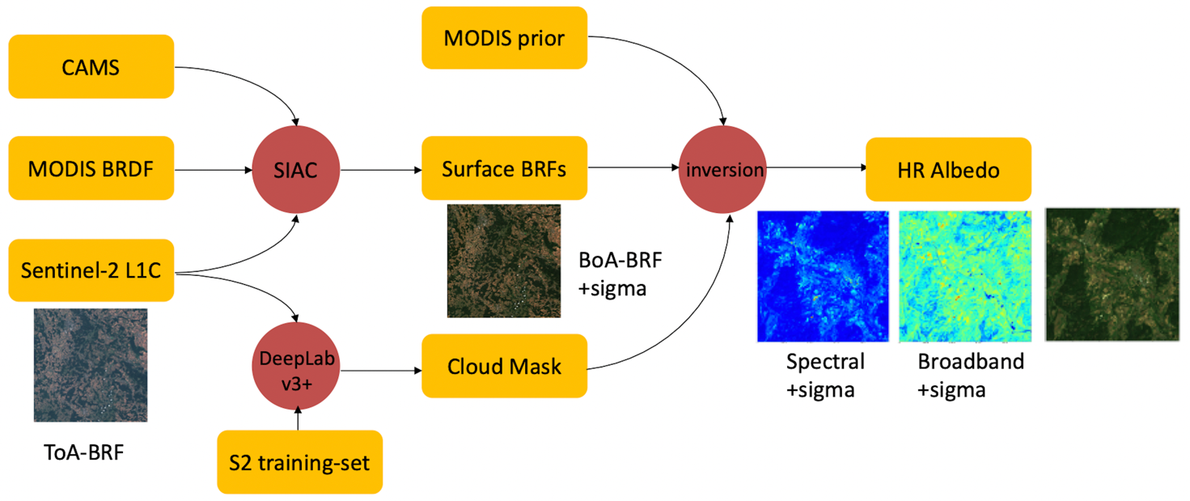
Figure 1. Overall processing chain of the HR-AlbedoMap system.

Processing System
All products described in this project were generated in the JASMIN/CEMS data processing environment which is provided by STFC-CEDA for climate and earth system science. JASMIN supports the data analysis requirements of the UK and European climate and earth system modelling community. It consists of multi-PetaByte fast storage co-located with data analysis computing facilities.
A good starting point for comprehensive further information is:
https://www.ceda.ac.uk/services/jasmin/

End User consultation: S2 Tile Overview
The HR-AlbedoMap project has produced 10m/20m S2 spectral and broadband hr-albedo products for 6 different end users (2 inter-governmental, 2 academic and 2 industrial): JRS Ispra, FAO-World Food Programme, University of Witwatserand, TERENO/University of Leipzig, Hummingbird Technology Ltd. and Treewise Ltd. respectively. The site names, S2 tile IDs, start and end dates of the requested high-resolution albedo products are listed in Table 1. The geo-locations of processed Sentinel-2 tile are shown in Figure 2.
Table 1. Site names, S2 tile IDs, Start data and End date of high-resolution albedo products that are requested from different end users.
Site Name | S2 Tile ID | Requestor | Start Date | End Date
Bergamo, Italy | 32TNR | JRC Ispra | 01/02/2020 | 31/05/2020
South Sudan | 36PVU,36PWU,36PVT,36PWT | FAO-World Food Programme | 01/11/2020 | 28/02/2021
Skukuza, S. Africa | 36JUT | U. of Witwatserand | 01/05/2018 | 31/08/2018
Leipzig, DE | 32UPC,32UQC,32UPB,32UQB | TERENO | 01/03/2018 | 30/06/2018
UK wheat belt | 30UXD,31UCU,30UXC,31UCT | Hummingbird | 01/05/2020 | 31/08/2020
Ukraine | 35UMR,35UNR,35UMQ,35UNQ | Hummingbird | 01/05/2020 | 31/08/2020
Tuxford | 30UXE | Treewise | 01/07/2020 | 31/10/2020
Weymouth | 30UWB | Treewise | 01/07/2020 | 31/10/2020
Melton | 30UXD | Treewise | 01/07/2020 | 31/10/2020
Southampton | 30UXB | Treewise | 01/07/2020 | 31/10/2020

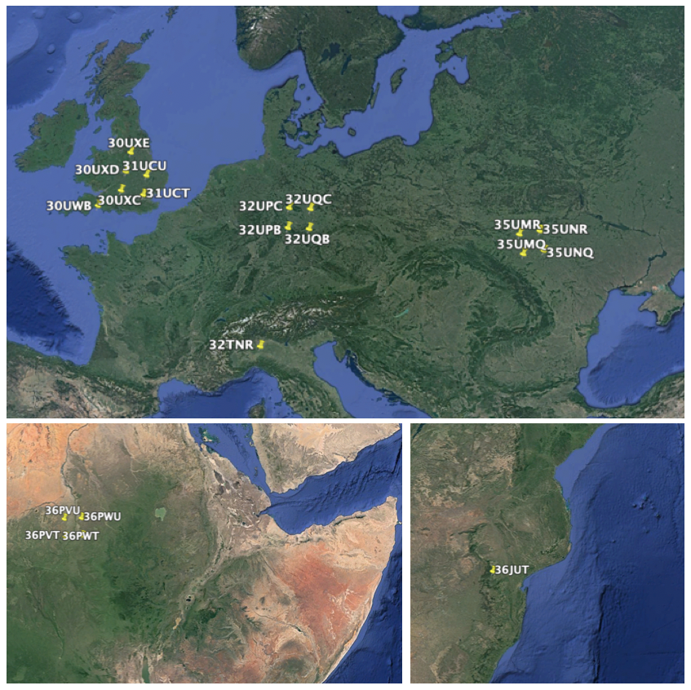
Figure 2. Geo-locations of processed Sentinel-2 tiles with tile number
(top: Europe; bottom left: East Africa; bottom right: South Africa).

Data Description

Naming Conventions
The produced spectral and broadband DHR/BHR products for each single data are stored in a SAFE format directory. The compact naming convention is arranged as follows:
MMM_MSIXXX_YYYYMMDDHHMMSS_Nxxyy_ROOO_Txxxxx_<Product Discriminator>_UCL.SAFE
This albedo product naming convention is consistent with the Sentinel L1C product naming convention, except for the _UCL.SAFE filename extension. Please refer to here for details about Sentinel-2 *.SAFE data naming convention.

Data Format
The HR-AlbedoMap spectral and broadband albedo image data are stored as jp2 (a compressed bitmap image saved in the JPEG 2000 Core Coding format) files. The jp2 output data file contains the projection parameters, spatial resolution, pixel size, no data value, and albedo values.

Product Types
Given a Sentinel-2 tile number and product date, the high-resolution albedo products include 6 spectral albedo products (bands 2,3,4,8A, 11 & 12), 3 broadband (VIS, NIR, Shortwave) albedo products, uncertainties of all of these albedo products, RGB preview browse image products are produced at 40m and animations use images resampled to 160m of each date for the original (left-hand-image) and gap-filled versions (right-hand-image) of the products.
The albedo products usually include (a) the original values with gaps where clouds are detected; (b) a gap-filled version. Some of the gap-filled products which have no data (i.e. >85% cloud cover) do not have uncertainty values.
Table 1 lists these individual products from Sentinel-2 tile 32TNR as an example to show only the available BHR_only products for a given tile and date. DHR products are not listed in this table, they have exactly the same data structure as the BHR products. Each product at 10m (S2 bands 2,3,4) is 10,000 x 10,000 pixels and for 20m products (S2 bands 8A, 11, 12) is 5,000 x 5,000.

Table 2. Examples of filename, data description of the HR-AlbedoMap BHR albedo products.
File name | Description | Scaling factor | No Data
T32TNR_20200312T102021B02_UCL_bhr.jp2 | B02 (490 nm) BHR | 1.e4 | -9999
T32TNR_20200312T102021B02_UCL_bhr-unc.jp2 | B02 BHR uncertainty | 1.e4 | -9999
T32TNR_20200312T102021B02_UCL_bhr_gapfilled.jp2 | Gap-filled B02 BHR | 1.e4 | -9999
T32TNR_20200312T102021B03_UCL_bhr.jp2 | B03 (560 nm) BHR | 1.e4 | -9999
T32TNR_20200312T102021B03_UCL_bhr-unc.jp2 | B03 BHR uncertainty | 1.e4 | -9999
T32TNR_20200312T102021B03_UCL_bhr_gapfilled.jp2 | Gap-filled B03 BHR | 1.e4 | -9999
T32TNR_20200312T102021B04_UCL_bhr.jp2 | B04 (665 nm) BHR | 1.e4 | -9999
T32TNR_20200312T102021B04_UCL_bhr-unc.jp2 | B04 BHR uncertainty | 1.e4 | -9999
T32TNR_20200312T102021B04_UCL_bhr_gapfilled.jp2 | Gap-filled B04 BHR | 1.e4 | -9999
T32TNR_20200312T102021B8A_UCL_bhr.jp2 | B8A (865 nm) BHR | 1.e4 | -9999
T32TNR_20200312T102021B8A_UCL_bhr-unc.jp2 | B8A BHR uncertainty | 1.e4 | -9999
T32TNR_20200312T102021B8A_UCL_bhr_gapfilled.jp2 | Gap-filled B8A BHR | 1.e4 | -9999
T32TNR_20200312T102021B11_UCL_bhr.jp2 | B11 (1610 nm) BHR | 1.e4 | -9999
T32TNR_20200312T102021B11_UCL_bhr-unc.jp2 | B11 BHR uncertainty | 1.e4 | -9999
T32TNR_20200312T102021B11_UCL_bhr_gapfilled.jp2 | Gap-filled B11 BHR | 1.e4 | -9999
T32TNR_20200312T102021B12_UCL_bhr.jp2 | B12 (2190 nm) BHR | 1.e4 | -9999
T32TNR_20200312T102021B12_UCL_bhr-unc.jp2 | B12 BHR uncertainty | 1.e4 | -9999
T32TNR_20200312T102021B12_UCL_bhr_gapfilled.jp2 | Gap-filled B12 BHR | 1.e4 | -9999
T32TNR_20200312T102021BVIS_UCL_bhr.jp2 | visible broadband BHR | 1.e4 | -9999
T32TNR_20200312T102021BVIS_UCL_bhr-unc.jp2 | visible broadband BHR uncertainty | 1.e4 | -9999
T32TNR_20200312T102021BVIS_UCL_bhr_gapfilled.jp2 | Gap-filled visible broadband BHR | 1.e4 | -9999
T32TNR_20200312T102021BNIR_UCL_bhr.jp2 | NIR broadband BHR | 1.e4 | -9999
T32TNR_20200312T102021BNIR_UCL_bhr-unc.jp2 | NIR broadband BHR uncertainty | 1.e4 | -9999
T32TNR_20200312T102021BNIR_UCL_bhr_gapfilled.jp2 | Gap-filled NIR broadband BHR | 1.e4 | -9999
T32TNR_20200312T102021BSW_UCL_bhr.jp2 | shortwave broadband BHR | 1.e4 | -9999
T32TNR_20200312T102021BSW_UCL_bhr-unc.jp2 | shortwave broadband BHR uncertainty | 1.e4 | -9999
T32TNR_20200312T102021BSW_UCL_bhr_gapfilled.jp2 | Gap-filled shortwave broadband BHR | 1.e4 | -9999

The HR-AlbedoMap processing chain does not perform albedo retrievals over Sentinel-2 tiles that are over 85% cloud covered. Therefore, for dates that have over 85% cloud coverage, the DHR and BHR maps are directly estimated from the gap-filling method that is introduced in the HR-AlbedoMap ATBD. In this case, albedo uncertainties cannot be obtained for these over 85% cloud-covered days, as uncertainty estimation is based on the retrieval outputs.

Available Products
Table 1 lists the Sentinel-2 tiles IDs and time ranges for the data processed for different end users. All the data are publicly available and can be retrieved from the following link: https://gws-access.jasmin.ac.uk/public/qa4ecv/hr_albedo/.
For each Sentinel-2 tile, there is an Overview folder at the top level (e.g. https://gws-access.jasmin.ac.uk/public/qa4ecv/hr_albedo/Bergamo/Overview/). This folder contains all the before/after gap-filled DHR/BHR RGB composition preview images. Also, there are animations (in mp4 format, which can only be directly displayed in the Chrome browser) showing time series of 1-to-1 comparison between the original retrieved albedo and gap-filled albedo RGB compositions. It is suggested that users view these time-series animation first, and then decide which data are of interest for them to download using “wget”.
The download link, quick view animation and information of data sizes for all the currently produced high-resolution albedo products are as follows:

- Download link for Bergamo (32TNR): 01/02/2020 to 31/05/2020
data size: 7.5G
https://gws-access.jasmin.ac.uk/public/qa4ecv/hr_albedo/Bergamo/
quick overview and sequence animation:
https://gws-access.jasmin.ac.uk/public/qa4ecv/hr_albedo/Bergamo/Overview/

- Download link for South Sudan: 01/11/2020 to 28/02/2021
data size: 12G
http://gws-access.jasmin.ac.uk/public/qa4ecv/hr_albedo/SouthSudan/36PVT
quick overview and sequence animation:
https://gws-access.jasmin.ac.uk/public/qa4ecv/hr_albedo/SouthSudan/36PVT/Overview/

data size: 8.8G
http://gws-access.jasmin.ac.uk/public/qa4ecv/hr_albedo/SouthSudan/36PVU
quick overview and sequence animation:
https://gws-access.jasmin.ac.uk/public/qa4ecv/hr_albedo/SouthSudan/36PVU/Overview/

data size: 6.5G
http://gws-access.jasmin.ac.uk/public/qa4ecv/hr_albedo/SouthSudan/36PWT
quick overview and sequence animation:
https://gws-access.jasmin.ac.uk/public/qa4ecv/hr_albedo/SouthSudan/36PWT/Overview/

http://gws-access.jasmin.ac.uk/public/qa4ecv/hr_albedo/SouthSudan/36PWU
data size: 8.4G
quick overview and sequence animation:
https://gws-access.jasmin.ac.uk/public/qa4ecv/hr_albedo/SouthSudan/36PWU/Overview/

- Download link for Skukuza: 01/05/2018 to 31/08/2018
http://gws-access.jasmin.ac.uk/public/qa4ecv/hr_albedo/Skukuza
data size: 8.2G
quick overview and sequence animation:
http://gws-access.jasmin.ac.uk/public/qa4ecv/hr_albedo/Skukuza/36JUT/Overview/

- Download link for Leipzig: 01/03/2018 to 30/06/2018
http://gws-access.jasmin.ac.uk/public/qa4ecv/hr_albedo/Leipzig/32UPB
data size: 5.4G
quick overview and sequence animation:
http://gws-access.jasmin.ac.uk/public/qa4ecv/hr_albedo/Leipzig/32UPB/Overview/

http://gws-access.jasmin.ac.uk/public/qa4ecv/hr_albedo/Leipzig/32UPC
data size: 6.0G
quick overview and sequence animation:
http://gws-access.jasmin.ac.uk/public/qa4ecv/hr_albedo/Leipzig/32UPC/Overview/

http://gws-access.jasmin.ac.uk/public/qa4ecv/hr_albedo/Leipzig/32UQB
data size: 11G
quick overview and sequence animation:
http://gws-access.jasmin.ac.uk/public/qa4ecv/hr_albedo/Leipzig/32UQB/Overview/

http://gws-access.jasmin.ac.uk/public/qa4ecv/hr_albedo/Leipzig/32UQC
data size: 9G
quick overview and sequence animation:
http://gws-access.jasmin.ac.uk/public/qa4ecv/hr_albedo/Leipzig/32UQC/Overview/

- Download link for UK Wheat Belt: 01/05/2020 to 31/08/2020
http://gws-access.jasmin.ac.uk/public/qa4ecv/hr_albedo/WheatBelt/30UXC
data size: 7.4G
quick overview and sequence animation:
http://gws-access.jasmin.ac.uk/public/qa4ecv/hr_albedo/WheatBelt/30UXC/Overview/

http://gws-access.jasmin.ac.uk/public/qa4ecv/hr_albedo/WheatBelt/30UXD
data size: 6.5G
quick overview and sequence animation:
http://gws-access.jasmin.ac.uk/public/qa4ecv/hr_albedo/WheatBelt/30UXD/Overview/

http://gws-access.jasmin.ac.uk/public/qa4ecv/hr_albedo/WheatBelt/31UCT
data size: 13G
quick overview and sequence animation:
http://gws-access.jasmin.ac.uk/public/qa4ecv/hr_albedo/WheatBelt/31UCT/Overview/

http://gws-access.jasmin.ac.uk/public/qa4ecv/hr_albedo/WheatBelt/31UCU
data size: 13G
quick overview and sequence animation:
http://gws-access.jasmin.ac.uk/public/qa4ecv/hr_albedo/WheatBelt/31UCU/Overview/

- Download link for Ukraine:01/05/2020 to 31/08/2020
http://gws-access.jasmin.ac.uk/public/qa4ecv/hr_albedo/Ukraine/35UMQ
data size: 7.6G
quick overview and sequence animation:
http://gws-access.jasmin.ac.uk/public/qa4ecv/hr_albedo/Ukraine/35UMQ/Overview/

http://gws-access.jasmin.ac.uk/public/qa4ecv/hr_albedo/Ukraine/35UMR
data size: 5.8G
quick overview and sequence animation:
http://gws-access.jasmin.ac.uk/public/qa4ecv/hr_albedo/Ukraine/35UMR/Overview/

http://gws-access.jasmin.ac.uk/public/qa4ecv/hr_albedo/Ukraine/35UNQ
data size: 6.5G
quick overview and sequence animation:
http://gws-access.jasmin.ac.uk/public/qa4ecv/hr_albedo/Ukraine/35UNQ/Overview/

http://gws-access.jasmin.ac.uk/public/qa4ecv/hr_albedo/Ukraine/35UNR
data size: 9.6G
quick overview and sequence animation:
http://gws-access.jasmin.ac.uk/public/qa4ecv/hr_albedo/Ukraine/35UNR/Overview/

- Download link for Tree Wise: 01/07/2020 to 31/10/2020
http://gws-access.jasmin.ac.uk/public/qa4ecv/hr_albedo/TreeWise/30UXD
data size: 5.3G
quick overview and sequence animation:
http://gws-access.jasmin.ac.uk/public/qa4ecv/hr_albedo/TreeWise/30UXD/Overview/

http://gws-access.jasmin.ac.uk/public/qa4ecv/hr_albedo/TreeWise/30UXB
data size: 5.7G
quick overview and sequence animation:
http://gws-access.jasmin.ac.uk/public/qa4ecv/hr_albedo/TreeWise/30UXB/Overview/

http://gws-access.jasmin.ac.uk/public/qa4ecv/hr_albedo/TreeWise/30UXE
data size: 7.0G
quick overview and sequence animation:
http://gws-access.jasmin.ac.uk/public/qa4ecv/hr_albedo/TreeWise/30UXE /Overview/

http://gws-access.jasmin.ac.uk/public/qa4ecv/hr_albedo/TreeWise/30UWB
data size: 13G
quick overview and sequence animation:
http://gws-access.jasmin.ac.uk/public/qa4ecv/hr_albedo/TreeWise/30UWB /Overview/

